

***INSTITUTE OF INFORMATION TECHNOLOGY***

***JAHANGIRNAGAR UNIVERSITY***

**Final Assignment**

**Submission Date :** 30/07/2021

**Course Tittle :** Probability and Statistics for Engineers.

**Course Code :** ICT - 2107

**Submitted To Submitted By**

Dr. Mohd. Muzibur Rahman Md. Shakil Hossain

Associate Professor Class Roll – 2023

IIT – JU Exam Roll – 192340

IIT – JU

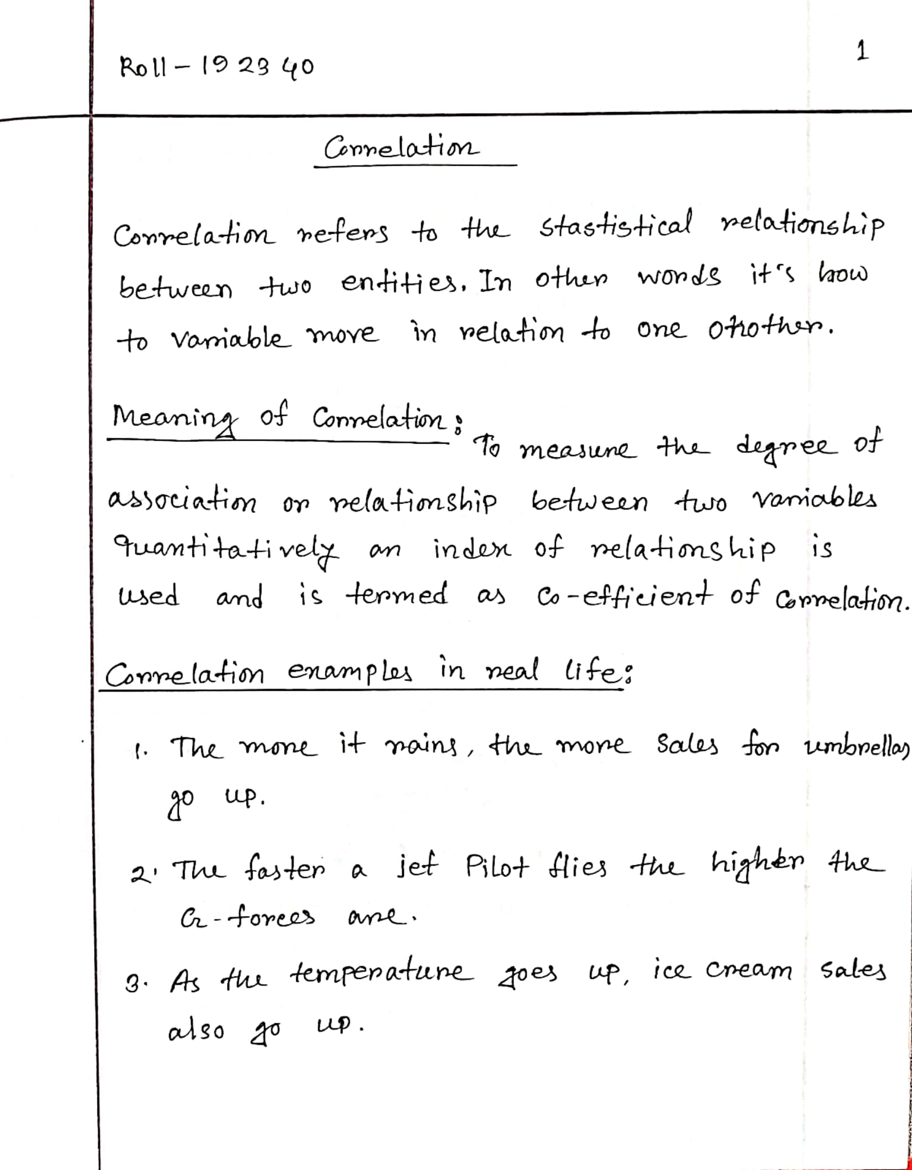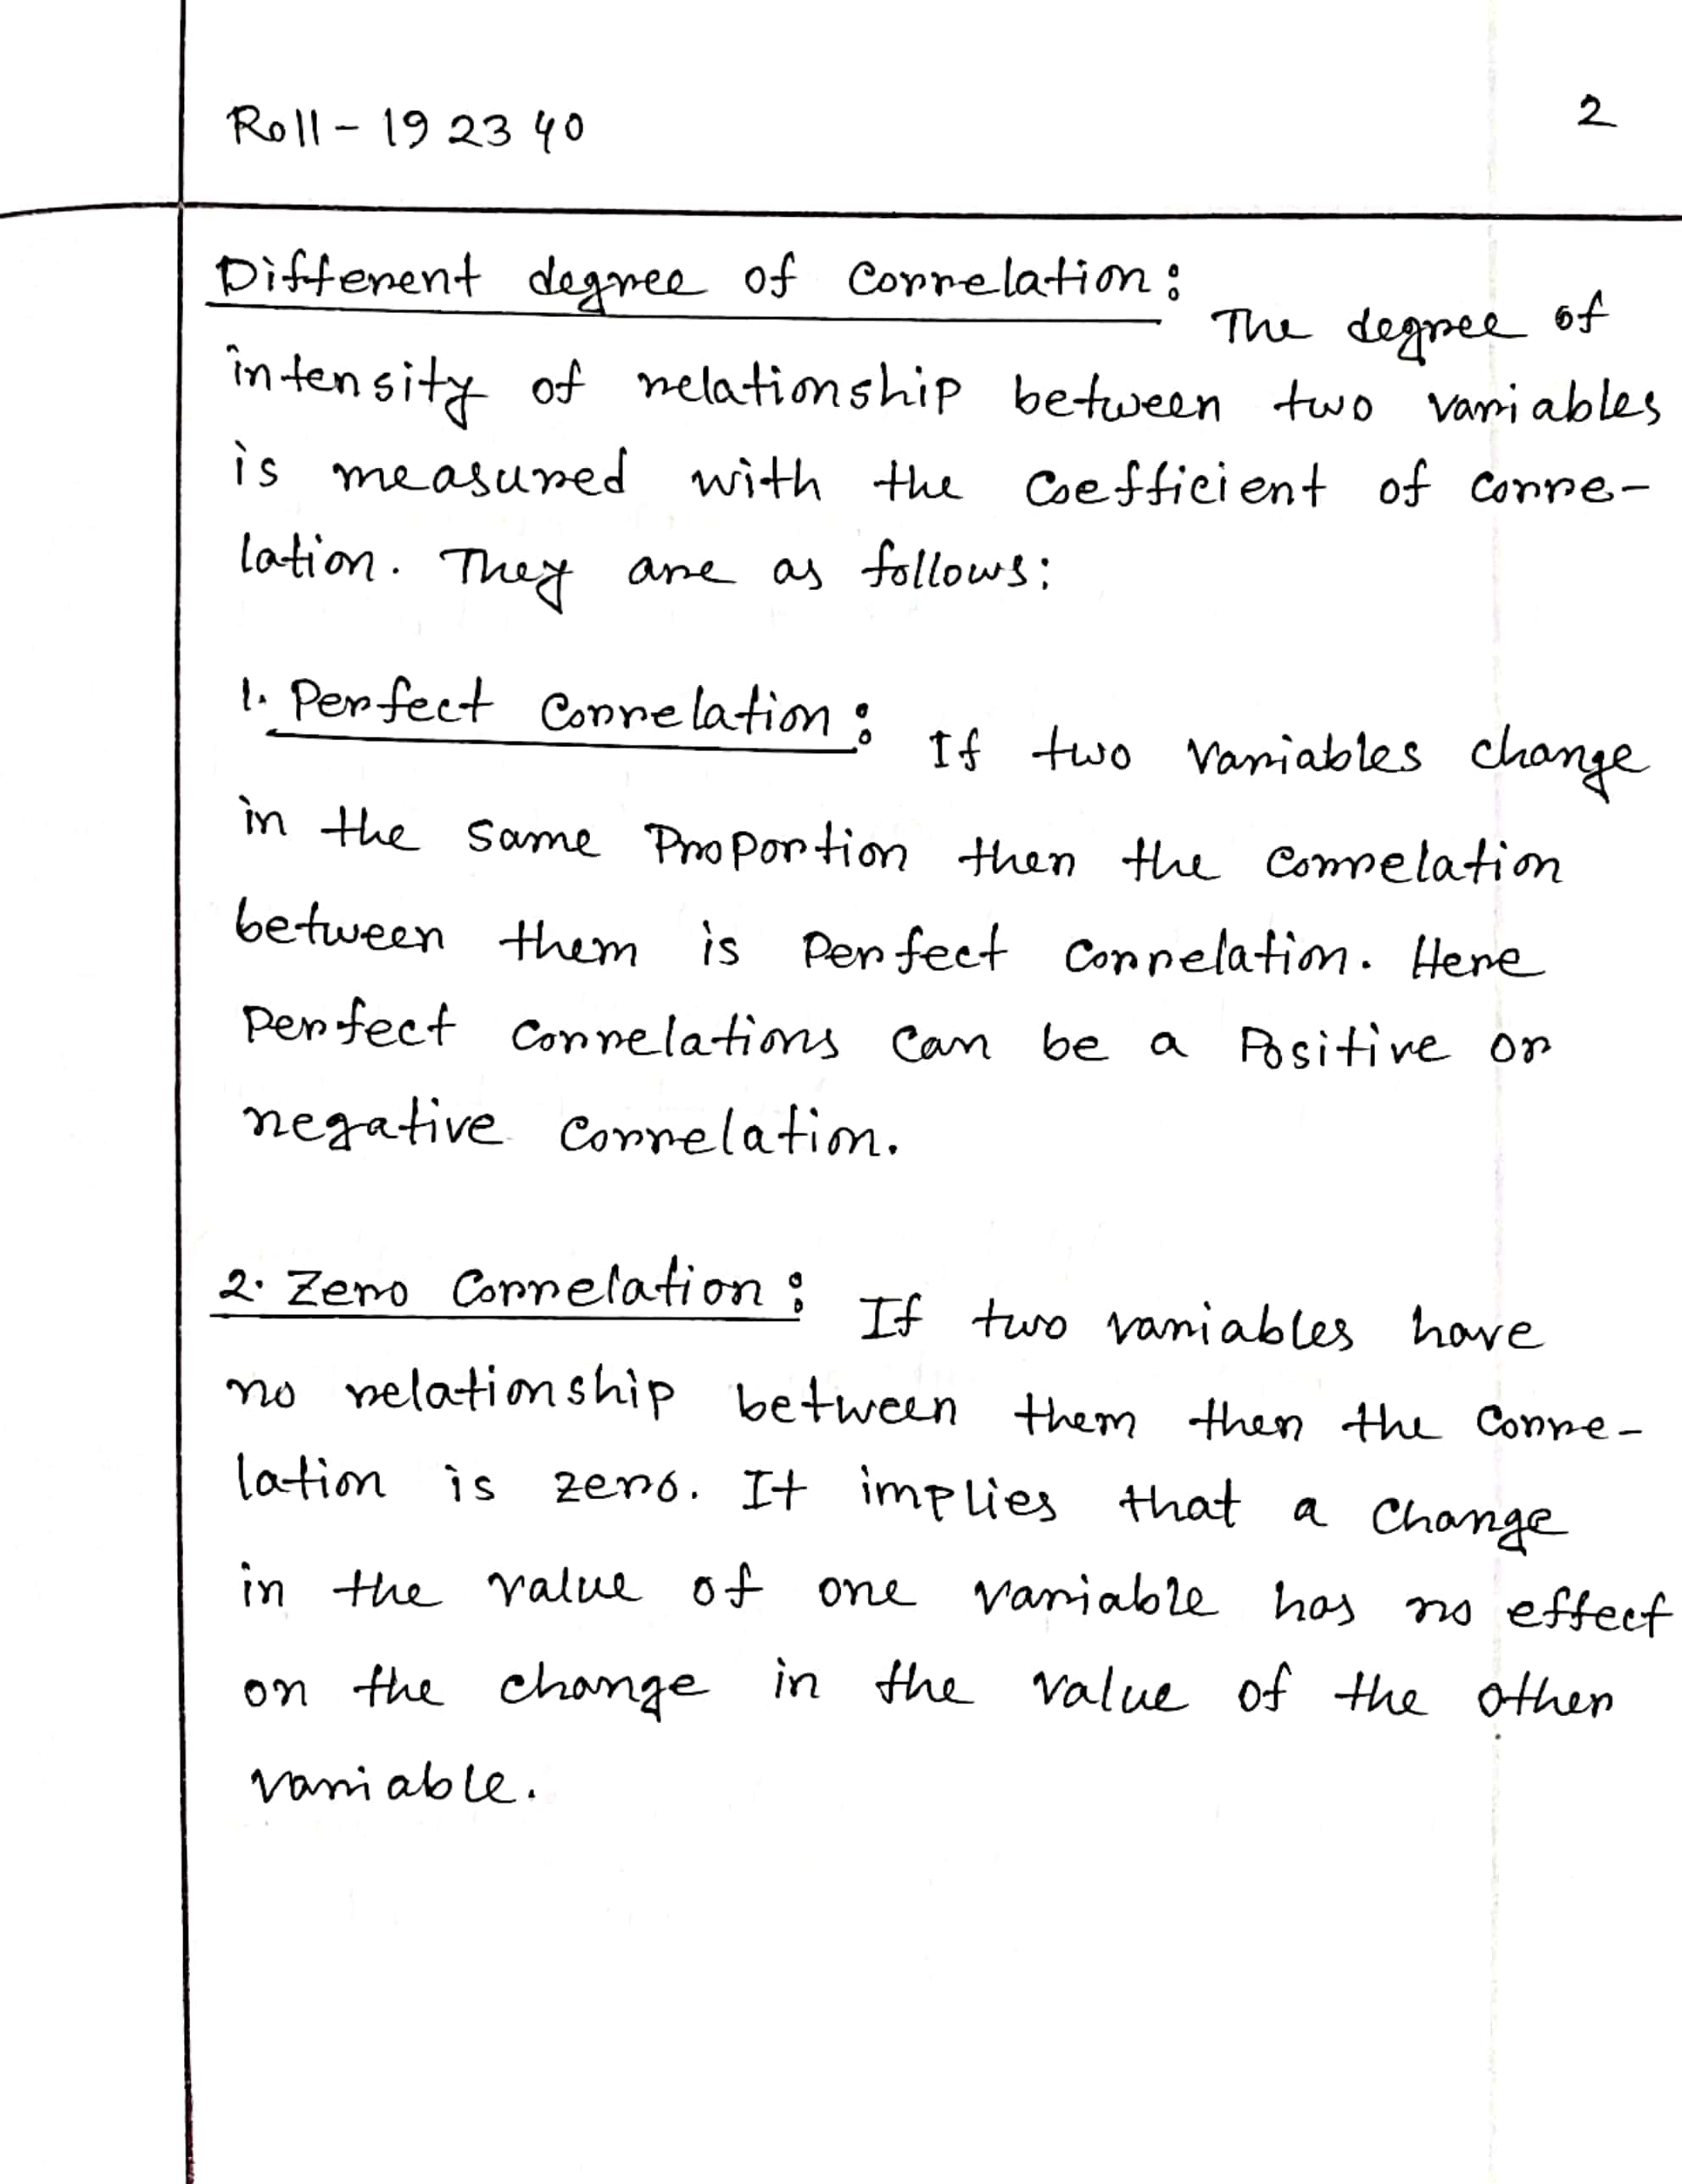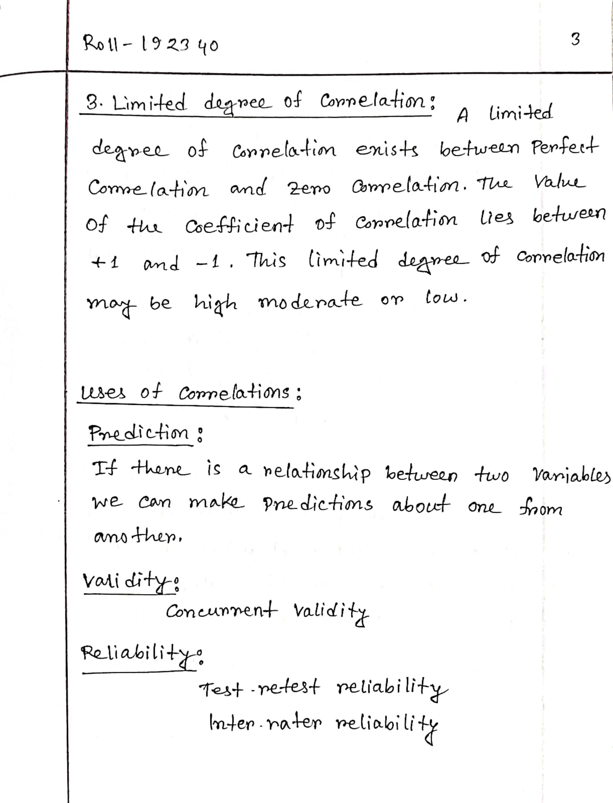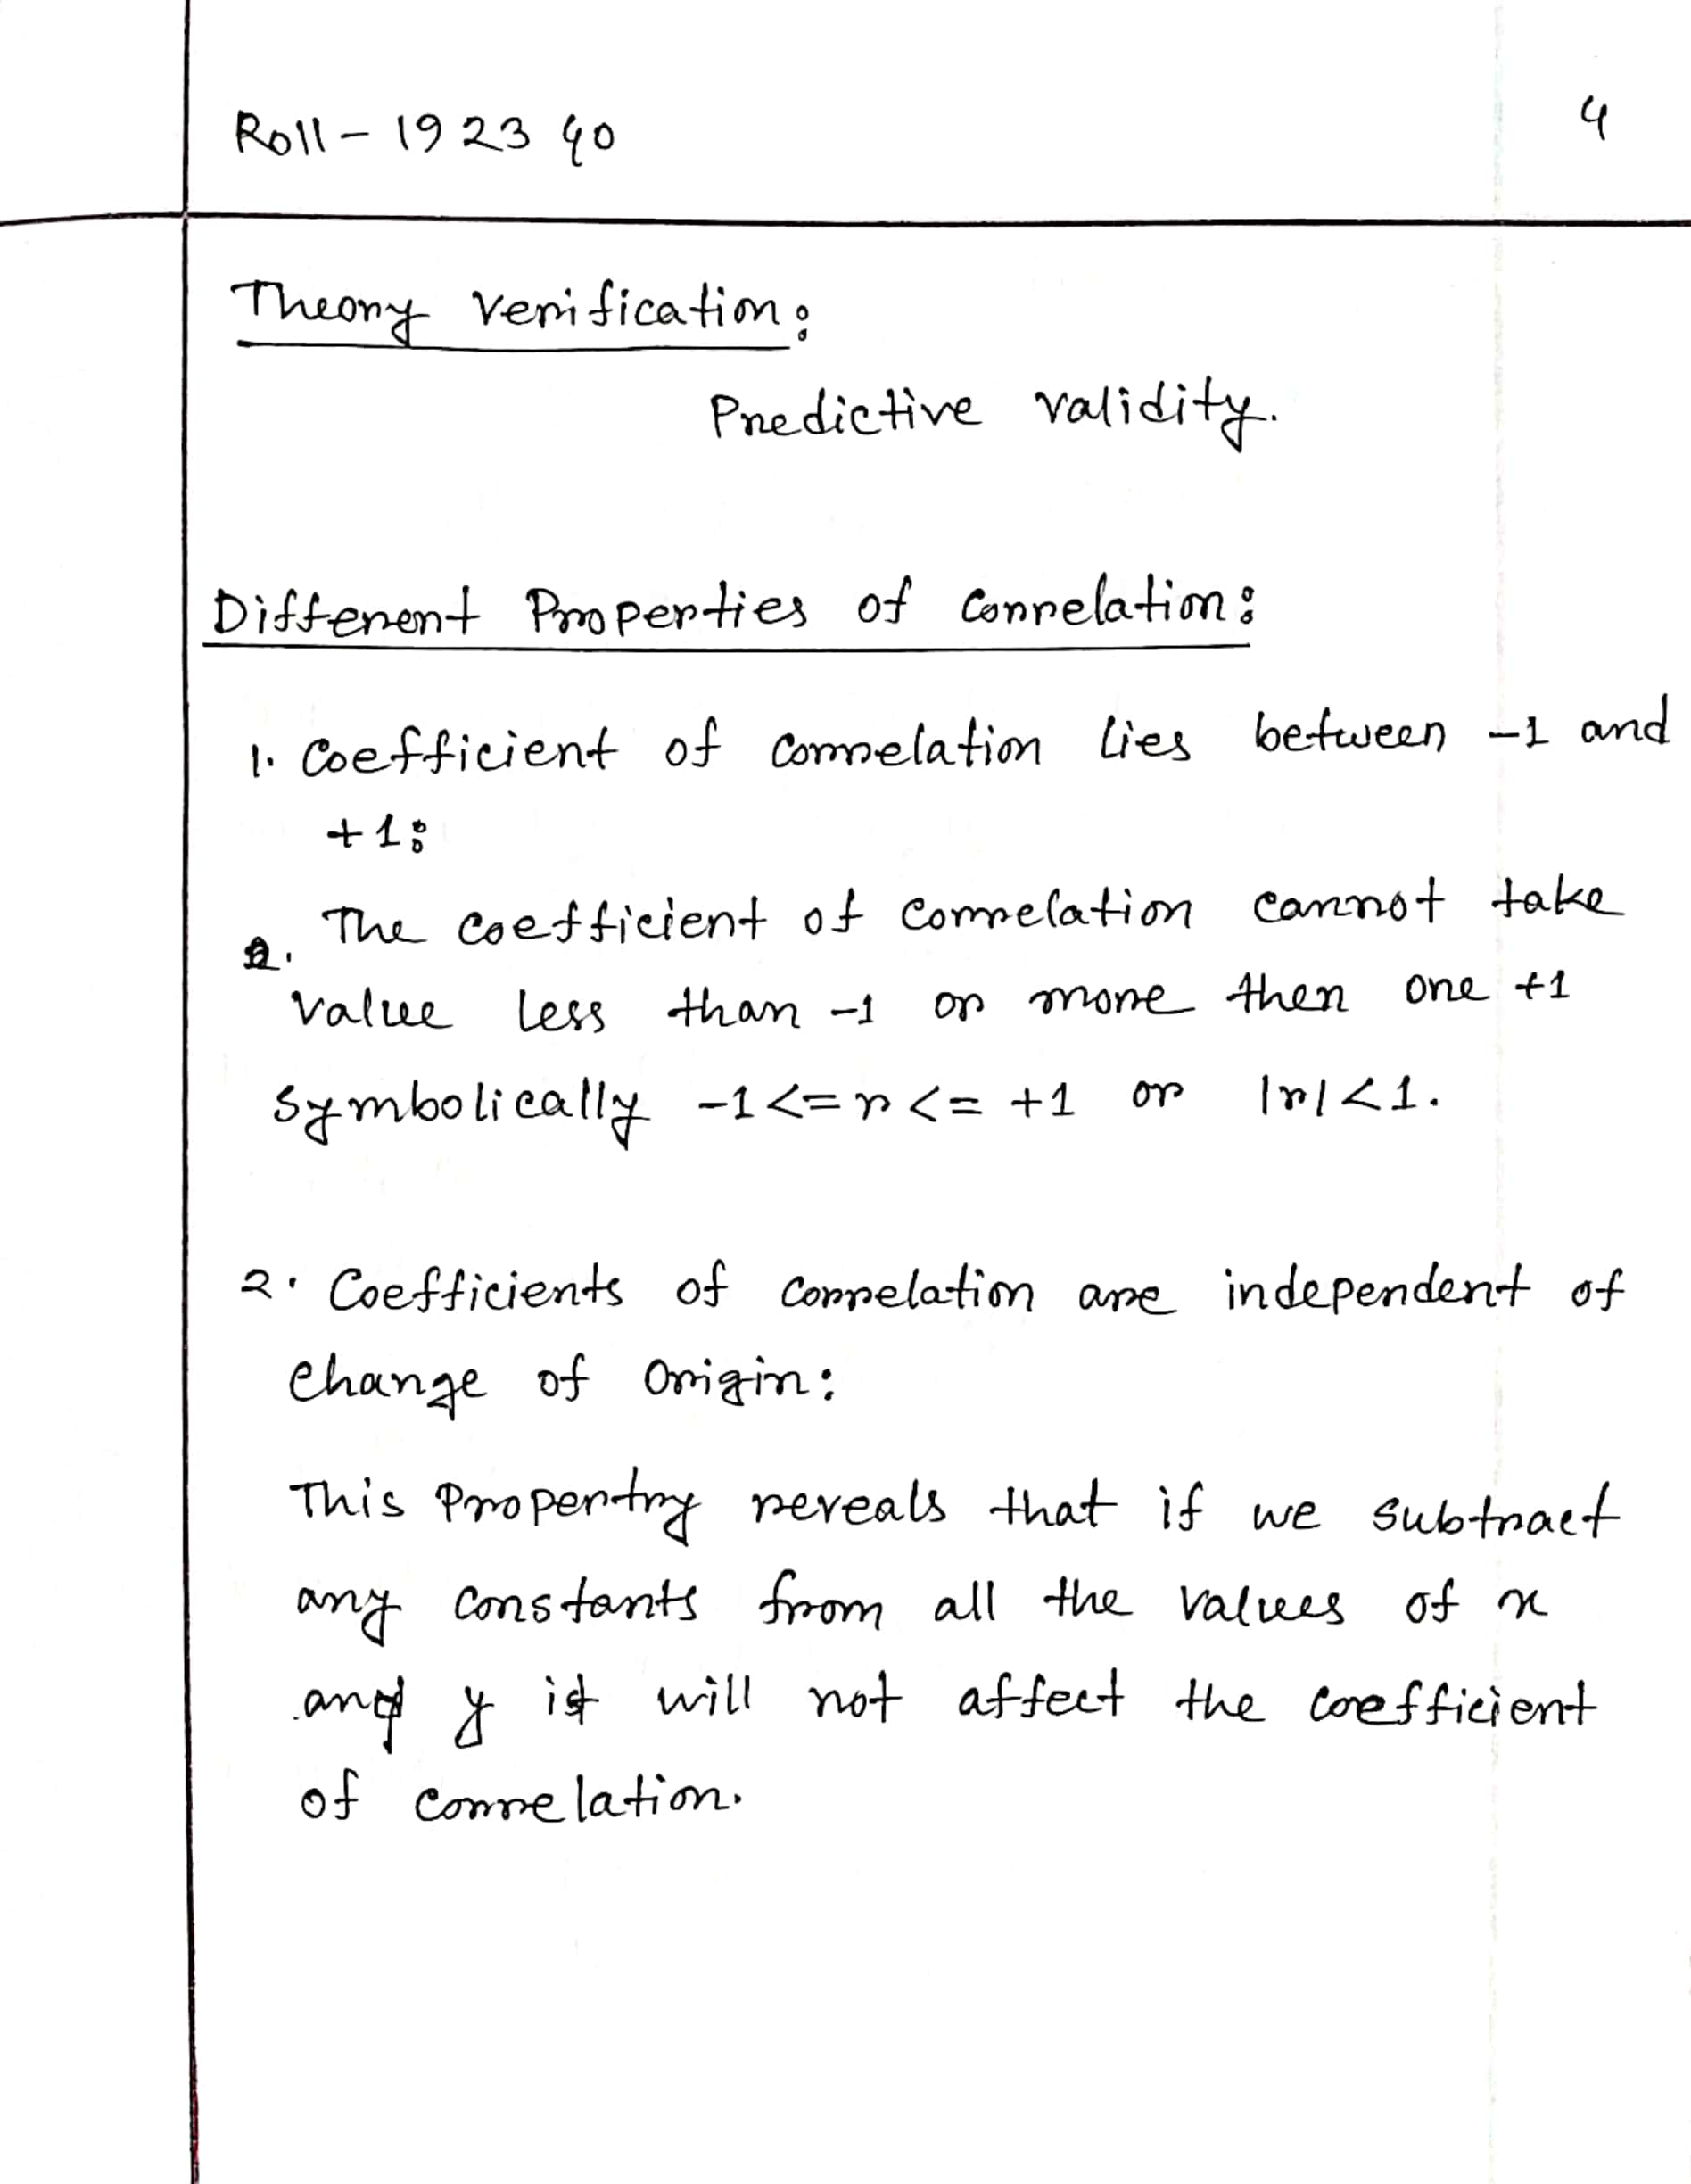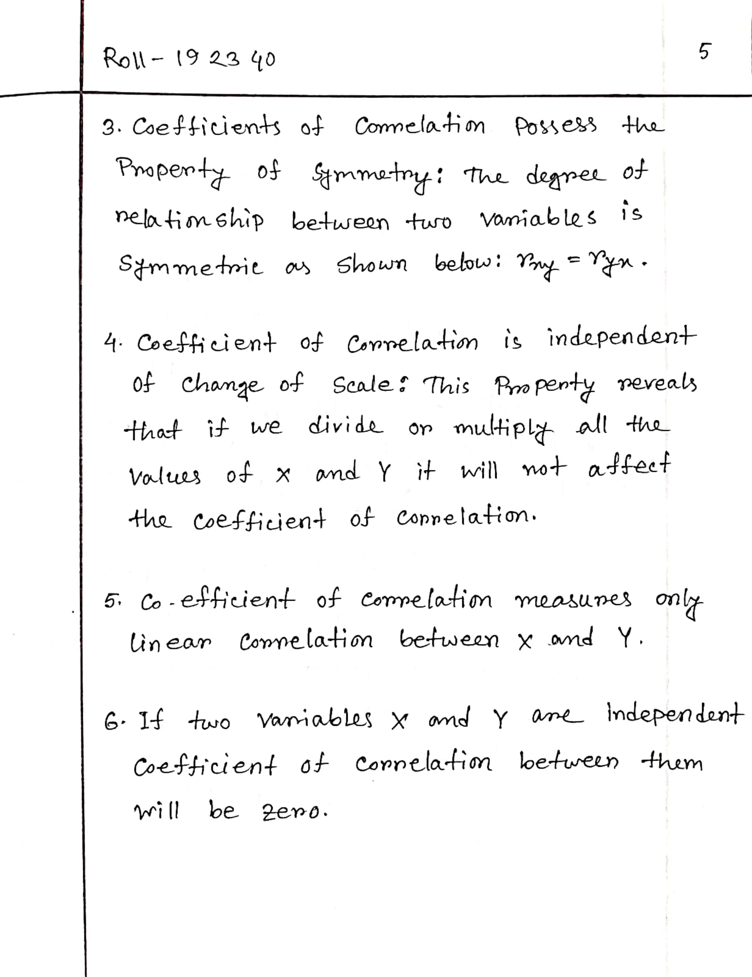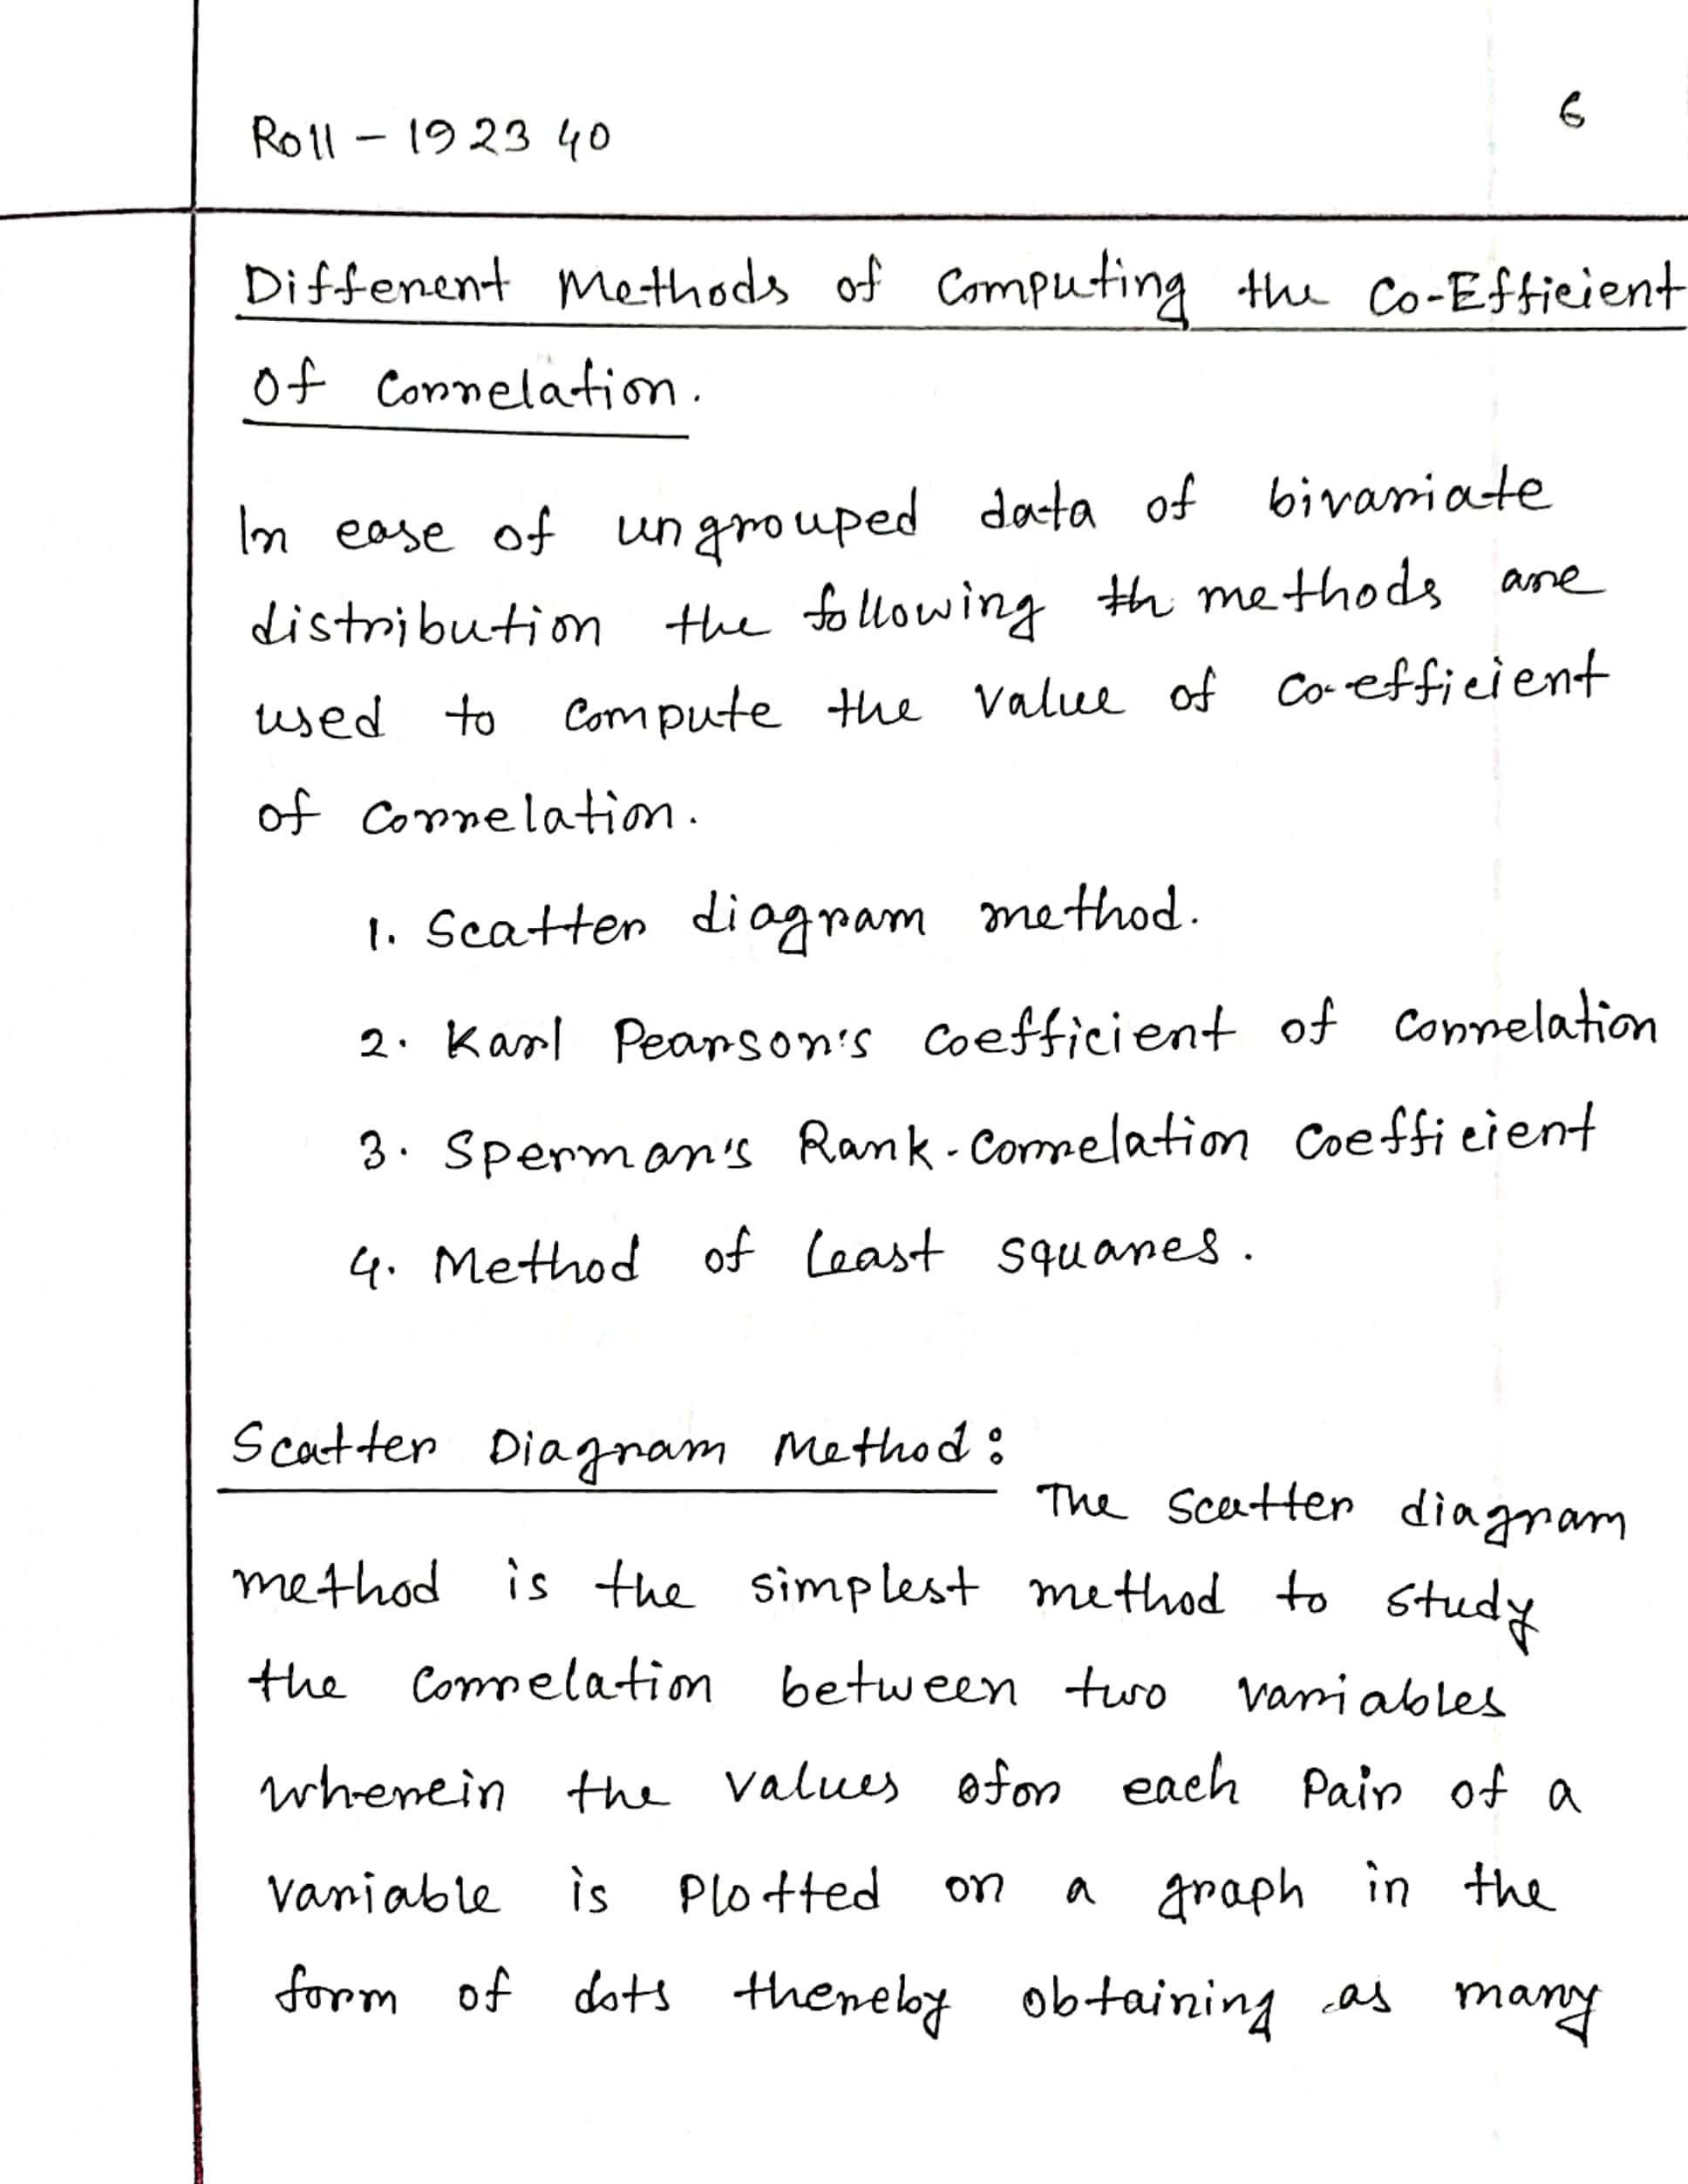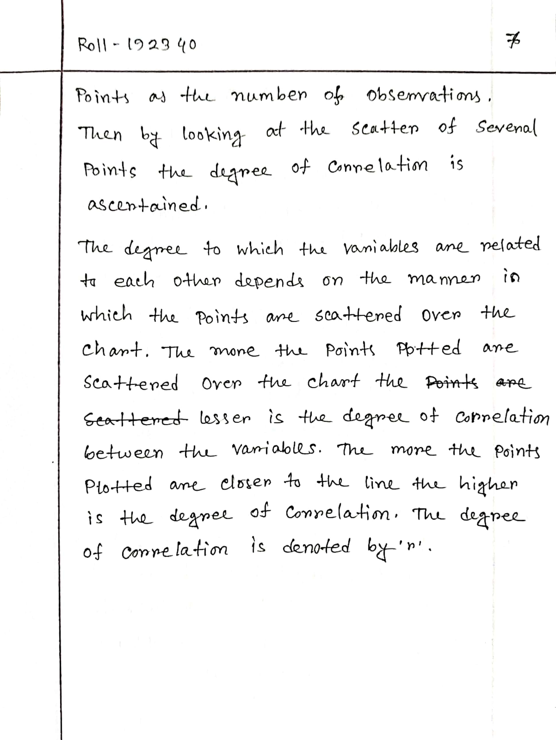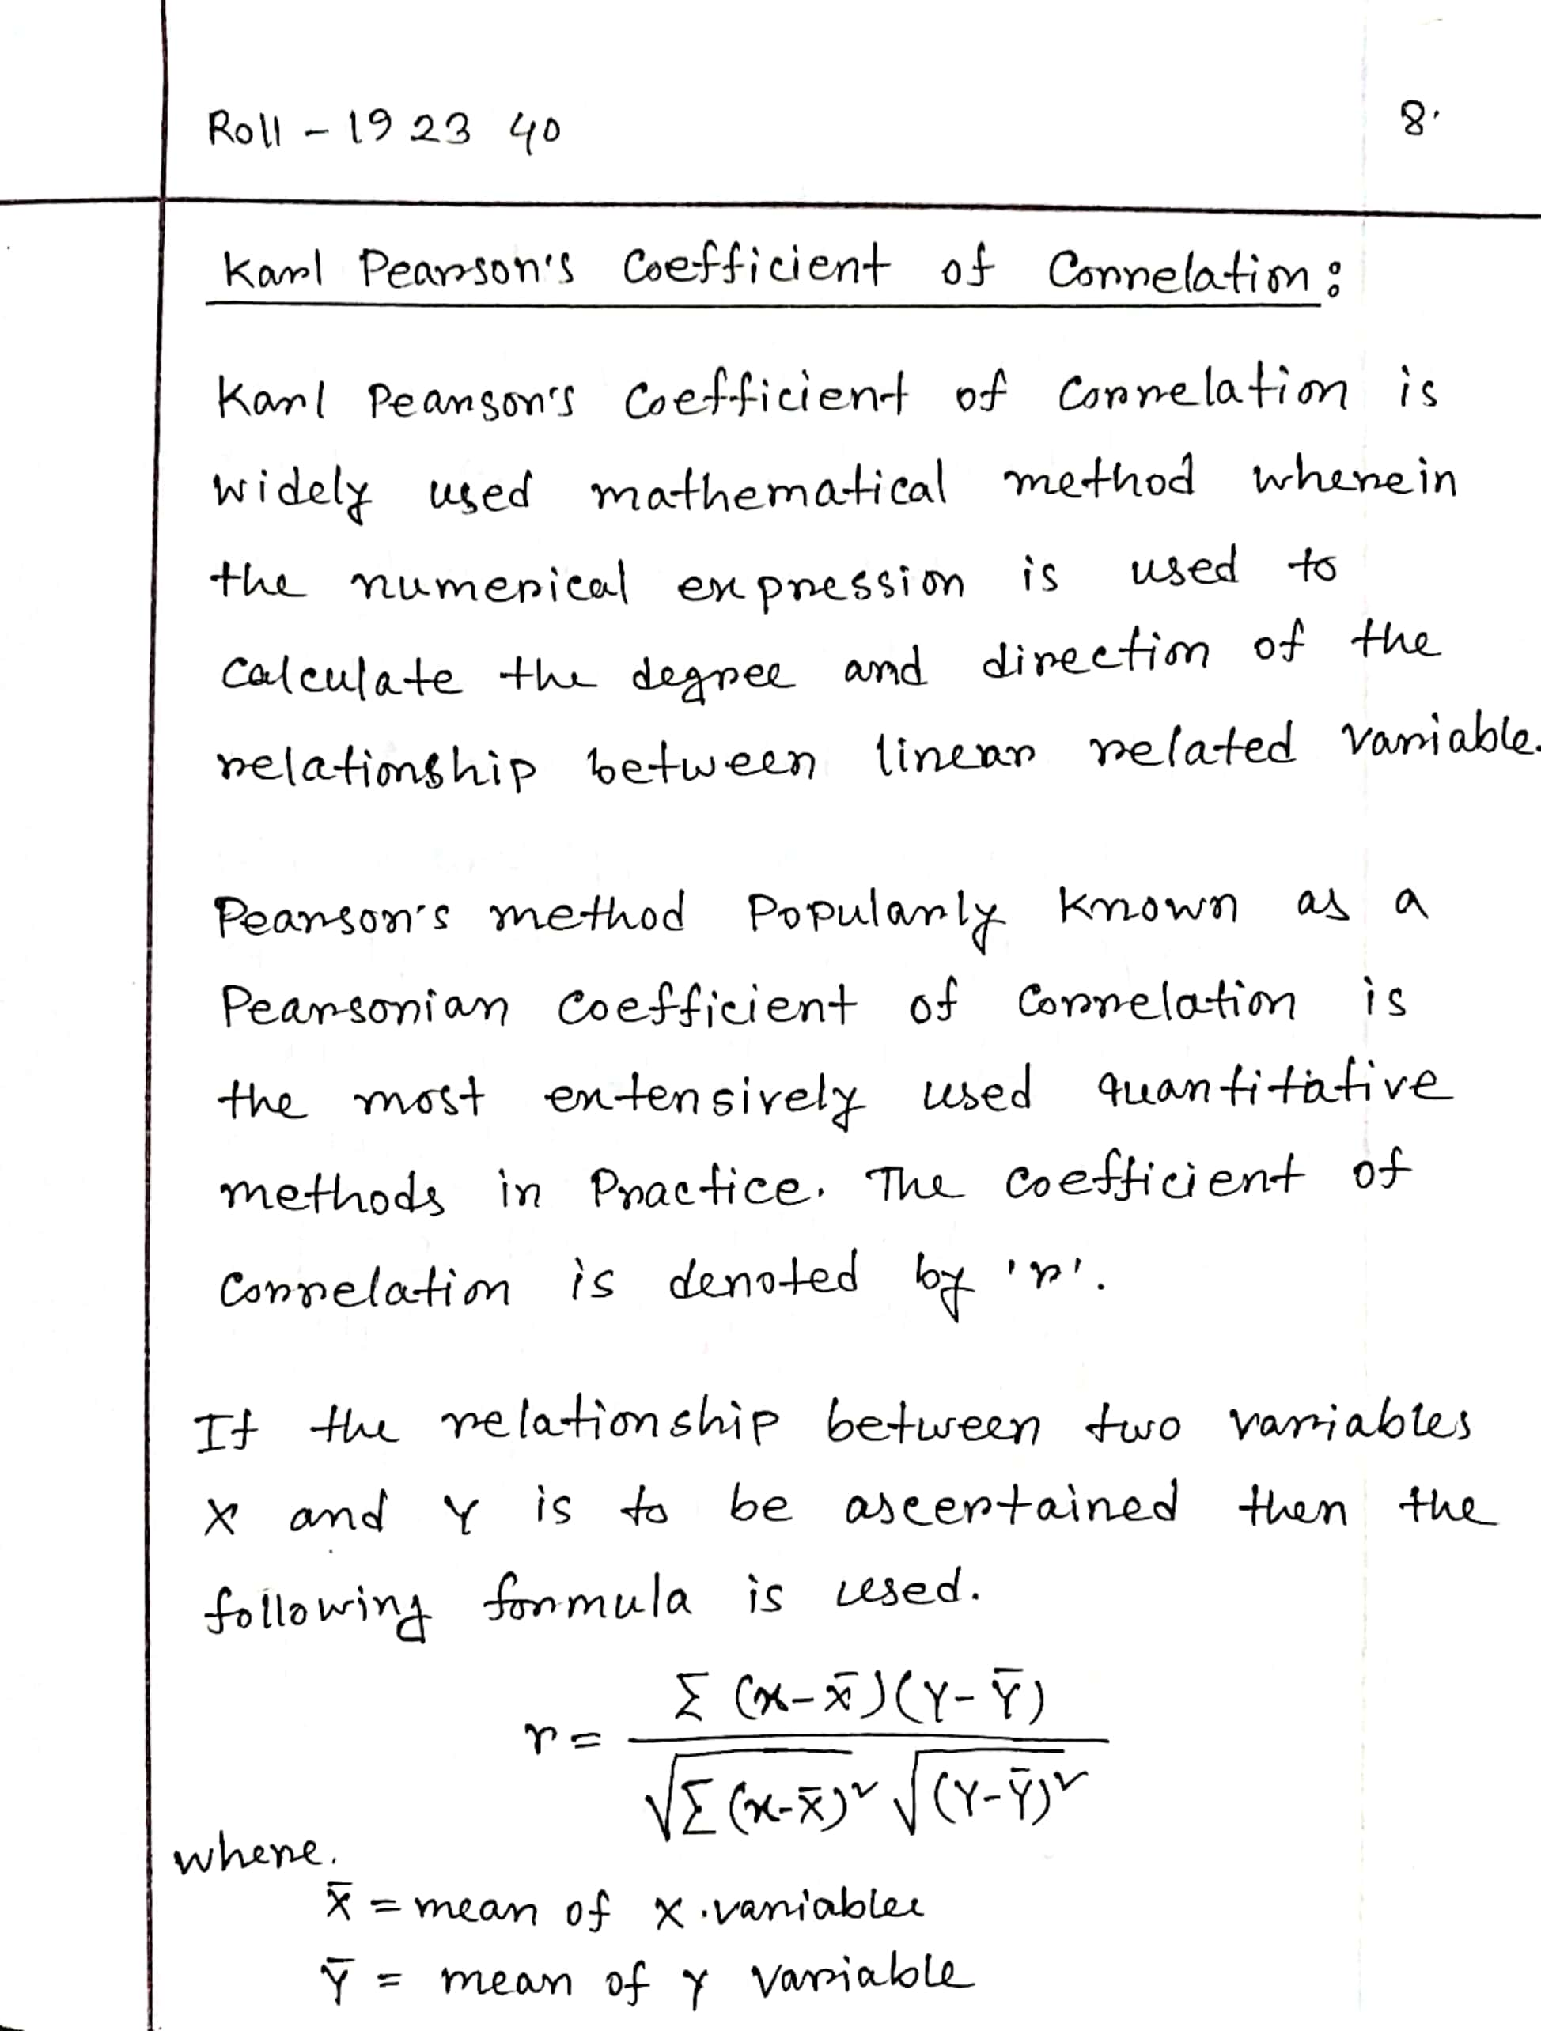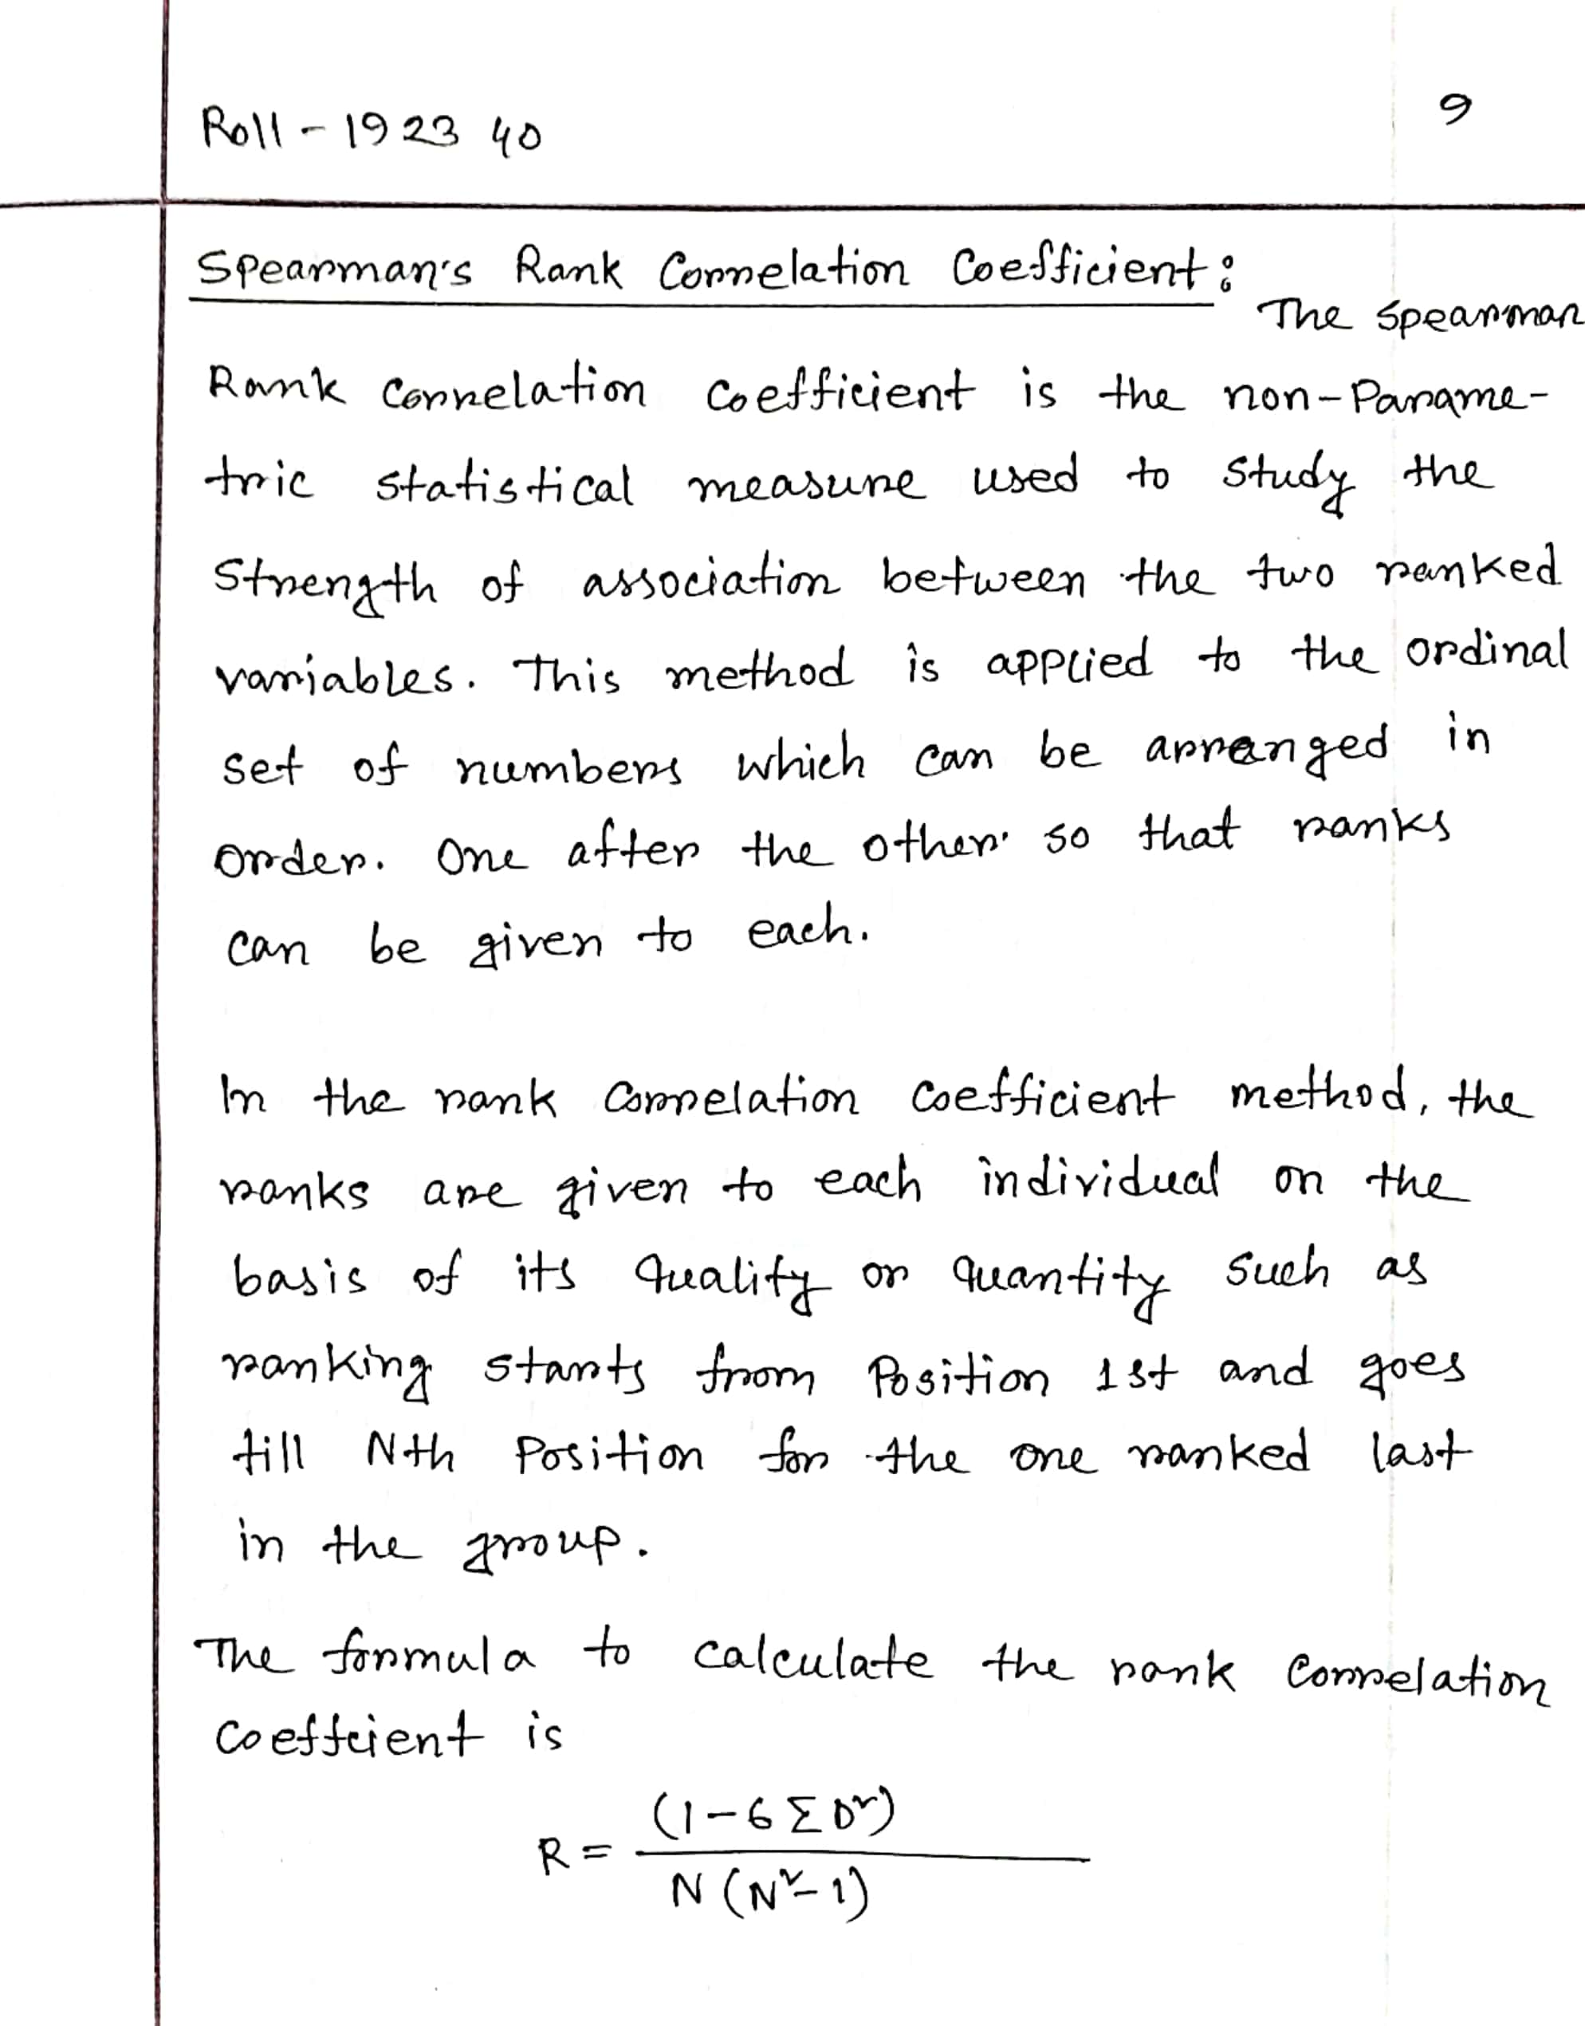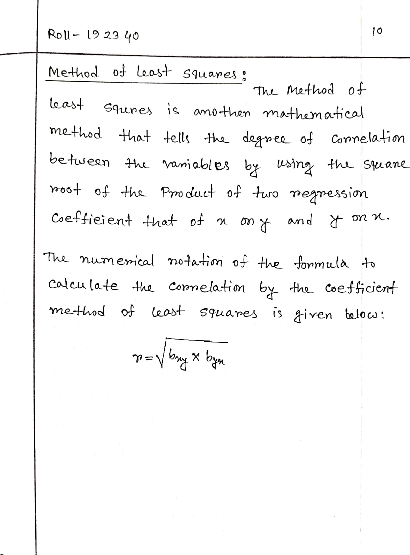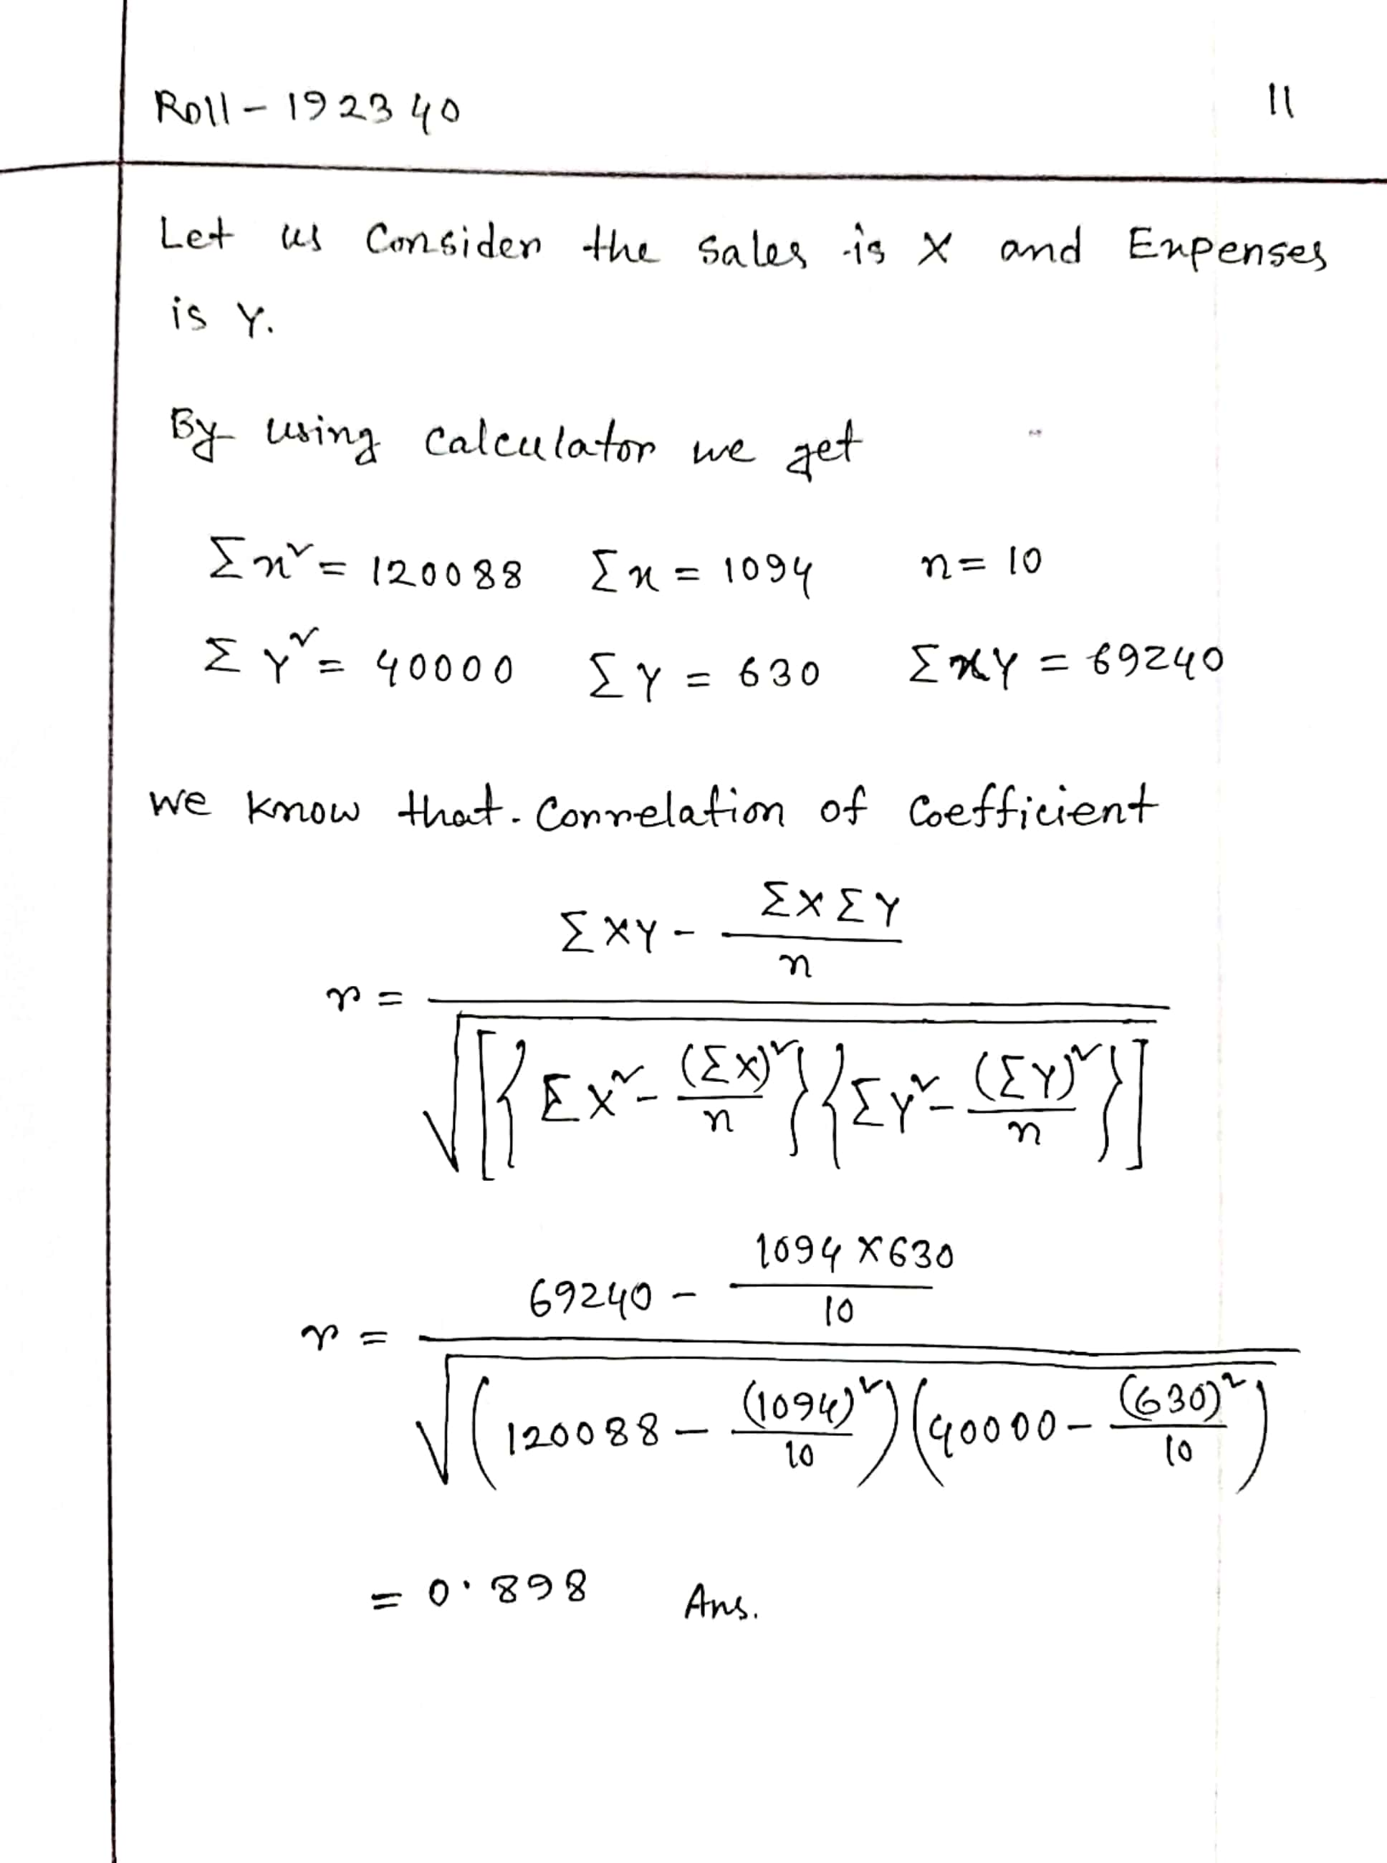

**THE END**